УНИВЕРСИТЕТ ИТМО

Факультет программной инженерии и компьютерной техники

Дисциплина «Дискретная математика»

**Курсовая работа**

«Синтез комбинационных систем»

Часть 2

Вариант 89

Студент

Волков Григорий Алексеевич

P3132

Преподаватель

Поляков Владимир Иванович

Санкт-Петербург, 2023 г.

# Задание

Построить комбинационную схему реализующую функцию *C* = *A* ∗ *B* (*A* и *B* по 2 бита, *C* — 4 бита) при *t* = 0 и *C* = *A/B* (*c*1*c*2 — остаток, *c*3*c*4 — частное) при *t* = 1. *B* 6= 0.

Таблица истинности

|  |  |  |  |  |  |  |  |  |  |
| --- | --- | --- | --- | --- | --- | --- | --- | --- | --- |
| № | *t* | *a*1 | *a*2 | *b*1 | *b*2 | *c*1 | *c*2 | *c*3 | *c*4 |
| 0 | 0 | 0 | 0 | 0 | 0 | d | d | d | d |
| 1 | 0 | 0 | 0 | 0 | 1 | 0 | 0 | 0 | 0 |
| 2 | 0 | 0 | 0 | 1 | 0 | 0 | 0 | 0 | 0 |
| 3 | 0 | 0 | 0 | 1 | 1 | 0 | 0 | 0 | 0 |
| 4 | 0 | 0 | 1 | 0 | 0 | d | d | d | d |
| 5 | 0 | 0 | 1 | 0 | 1 | 0 | 0 | 0 | 1 |
| 6 | 0 | 0 | 1 | 1 | 0 | 0 | 0 | 1 | 0 |
| 7 | 0 | 0 | 1 | 1 | 1 | 0 | 0 | 1 | 1 |
| 8 | 0 | 1 | 0 | 0 | 0 | d | d | d | d |
| 9 | 0 | 1 | 0 | 0 | 1 | 0 | 0 | 1 | 0 |
| 10 | 0 | 1 | 0 | 1 | 0 | 0 | 1 | 0 | 0 |
| 11 | 0 | 1 | 0 | 1 | 1 | 0 | 1 | 1 | 0 |
| 12 | 0 | 1 | 1 | 0 | 0 | d | d | d | d |
| 13 | 0 | 1 | 1 | 0 | 1 | 0 | 0 | 1 | 1 |
| 14 | 0 | 1 | 1 | 1 | 0 | 0 | 1 | 1 | 0 |
| 15 | 0 | 1 | 1 | 1 | 1 | 1 | 0 | 0 | 1 |
| 16 | 1 | 0 | 0 | 0 | 0 | d | d | d | d |
| 17 | 1 | 0 | 0 | 0 | 1 | 0 | 0 | 0 | 0 |
| 18 | 1 | 0 | 0 | 1 | 0 | 0 | 0 | 0 | 0 |
| 19 | 1 | 0 | 0 | 1 | 1 | 0 | 0 | 0 | 0 |
| 20 | 1 | 0 | 1 | 0 | 0 | d | d | d | d |
| 21 | 1 | 0 | 1 | 0 | 1 | 0 | 0 | 0 | 1 |
| 22 | 1 | 0 | 1 | 1 | 0 | 0 | 1 | 0 | 0 |
| 23 | 1 | 0 | 1 | 1 | 1 | 0 | 1 | 0 | 0 |
| 24 | 1 | 1 | 0 | 0 | 0 | d | d | d | d |
| 25 | 1 | 1 | 0 | 0 | 1 | 0 | 0 | 1 | 0 |
| 26 | 1 | 1 | 0 | 1 | 0 | 0 | 0 | 0 | 1 |
| 27 | 1 | 1 | 0 | 1 | 1 | 1 | 0 | 0 | 0 |
| 28 | 1 | 1 | 1 | 0 | 0 | d | d | d | d |
| 29 | 1 | 1 | 1 | 0 | 1 | 0 | 0 | 1 | 1 |
| 30 | 1 | 1 | 1 | 1 | 0 | 0 | 1 | 0 | 1 |
| 31 | 1 | 1 | 1 | 1 | 1 | 0 | 0 | 0 | 1 |

# Минимизация булевых функций на картах Карно

b1b2 b1b2

|  |  |  |  |
| --- | --- | --- | --- |
| d |  |  |  |
| d |  |  |  |
| d |  | 1 |  |
| d |  |  |  |

00 01 11 10 00 01 11 10

|  |  |  |  |
| --- | --- | --- | --- |
| d |  |  |  |
| d |  |  |  |
| d |  |  |  |
| d |  | 1 |  |

00

a1a2 01

11

10

*t=0 t=1*

*c1 = a1a2b1b2t* ∨ *a1a2b1b2t (SQ=12)*

b1b2 b1b2

|  |  |  |  |
| --- | --- | --- | --- |
| d | 0 | 0 | 0 |
| d | 0 | 0 | 0 |
| d | 0 | 0 |  |
| d | 0 |  |  |

00 01 11 10 00 01 11 10

|  |  |  |  |
| --- | --- | --- | --- |
| d | 0 | 0 | 0 |
| d | 0 |  |  |
| d | 0 | 0 |  |
| d | 0 | 0 | 0 |

00

a1a2 01

11

10

*t=0 t=1*

*c2 = b1 (a1* ∨ *t) (a2* ∨ *t) (a1* ∨ *a2* ∨ *b2) (SQ=11)*

b1b2 b1b2

|  |  |  |  |
| --- | --- | --- | --- |
| d | 0 | 0 | 0 |
| d | 0 |  |  |
| d |  | 0 |  |
| d |  |  | 0 |

00 01 11 10 00 01 11 10

|  |  |  |  |
| --- | --- | --- | --- |
| d | 0 | 0 | 0 |
| d | 0 | 0 | 0 |
| d |  | 0 | 0 |
| d |  | 0 | 0 |

00

a1a2 01

11

10

*t=0 t=1*

*c3 = (a1* ∨ *a2) (a1* ∨ *b1) (a2* ∨ *b2) (b1* ∨ *t) (a1* ∨ *a2* ∨ *b1* ∨ *b2) (SQ=17)*

b1b2 b1b2

|  |  |  |  |
| --- | --- | --- | --- |
| d | 0 | 0 | 0 |
| d |  |  | 0 |
| d |  |  | 0 |
| d | 0 | 0 | 0 |

00 01 11 10 00 01 11 10

|  |  |  |  |
| --- | --- | --- | --- |
| d | 0 | 0 | 0 |
| d |  | 0 | 0 |
| d |  |  |  |
| d | 0 | 0 |  |

00

a1a2 01

11

10

*t=0 t=1*

*c4 = (a2* ∨ *b2) (b2* ∨ *t) (a1* ∨ *b1* ∨ *t) (SQ=10)*

# Преобразование системы булевых функций

*c1 = a1a2b1b2t* ∨ *a1a2b1b2t (SQC1=12)*

*c2 = b1 (a1* ∨ *t) (a2* ∨ *t) (a1* ∨ *a2* ∨ *b2) (SQC2=11)*

*c3 = (a1* ∨ *a2) (a1* ∨ *b1) (a2* ∨ *b2) (b1* ∨ *t) (a1* ∨ *a2* ∨ *b1* ∨ *b2) (SQC3=17)*

*c4 = (a2* ∨ *b2) (b2* ∨ *t) (a1* ∨ *b1* ∨ *t) (SQC4=10)*

(SQ = 50)

Проведем раздельную факторизацию системы.

*c1 =a1b1b2 (a2t* ∨ *a2t) (SQC1=10)*

*c2 = b1 (a1* ∨ *t) (a2* ∨ *t) (a1* ∨ *a2* ∨ *b2) (SQC2=11)*

*c3 = (a1* ∨ *b1) (a2* ∨ *a1b2) (b1* ∨ *t (a1* ∨ *a2* ∨ *b1* ∨ *b2) ) (SQC3=16)*

*c4 = (a2* ∨ *b2) (b2* ∨ *t) (a1* ∨ *b1* ∨ *t) (SQC4=10)*

(SQ = 47)

Проведем совместную декомпозицию системы.

*φ0 = a1b2 φ0 = a1* ∨ *b2*

*φ0 = a1b2 (SQ φ0=2)*

*c1 = φ0b1(a2t* ∨ *a2t) (SQC1=9)*

*c2 = b1 (a1* ∨ *t) (a2* ∨ *t) (φ0* ∨ *a2) (SQC2=10)*

*c3 = (a1* ∨ *b1) (φ0* ∨ *a2) (b1* ∨ *t (φ0* ∨ *a2)) (SQC3=13)*

*c4 = (a2* ∨ *b2) (b2* ∨ *t) (a1* ∨ *b1* ∨ *t) (SQC4=10)*

(SQ = 45)

Проведем совместную декомпозицию системы.

*φ1 = φ0* ∨*a2*

*φ0 = a1b2 (SQ φ0=2)*

*c1 = φ0b1(a2t* ∨ *a2t) (SQC1=9)*

*c4 = (a2* ∨ *b2) (b2* ∨ *t) (a1* ∨ *b1* ∨ *t) (SQC4=10)*

*φ1 = φ0* ∨*a2*  *(SQ φ1=2)*

*c2 = φ1 b1 (a1* ∨ *t) (a2* ∨ *t) (SQC2=8)*

*c3 = (a1* ∨ *b1) (φ0* ∨ *a2) (b1* ∨ *φ1* *t ) (SQC3=11)*

(SQ = 43)

Проведем совместную декомпозицию системы.

*φ2 = a2 t φ2 =* *a2* ∨*t*

*φ2 = a2 t (SQ φ2=2)*

*φ0 = a1b2 (SQ φ0=2)*

*c1 = φ0b1(φ2* ∨ *a2t) (SQC1=7)*

*c4 = (a2* ∨ *b2) (b2* ∨ *t) (a1* ∨ *b1* ∨ *t) (SQC4=10)*

*φ1 = φ0* ∨*a2*  *(SQ φ1=2)*

*c2 = φ1 φ2 b1 (a1* ∨ *t) (SQC2=6)*

*c3 = (a1* ∨ *b1) (φ0* ∨ *a2) (b1* ∨ *φ1* *t ) (SQC3=11)*

(SQ = 42)

Синтез комбинационной схемы в булевом базисе

Будем анализировать схему на следующем наборе аргументов:

*a*1 = 1*, a*2 = 1*, b*1 = 1*, b*2 = 1*, t* = 0

Выходы схемы из таблицы истинности:

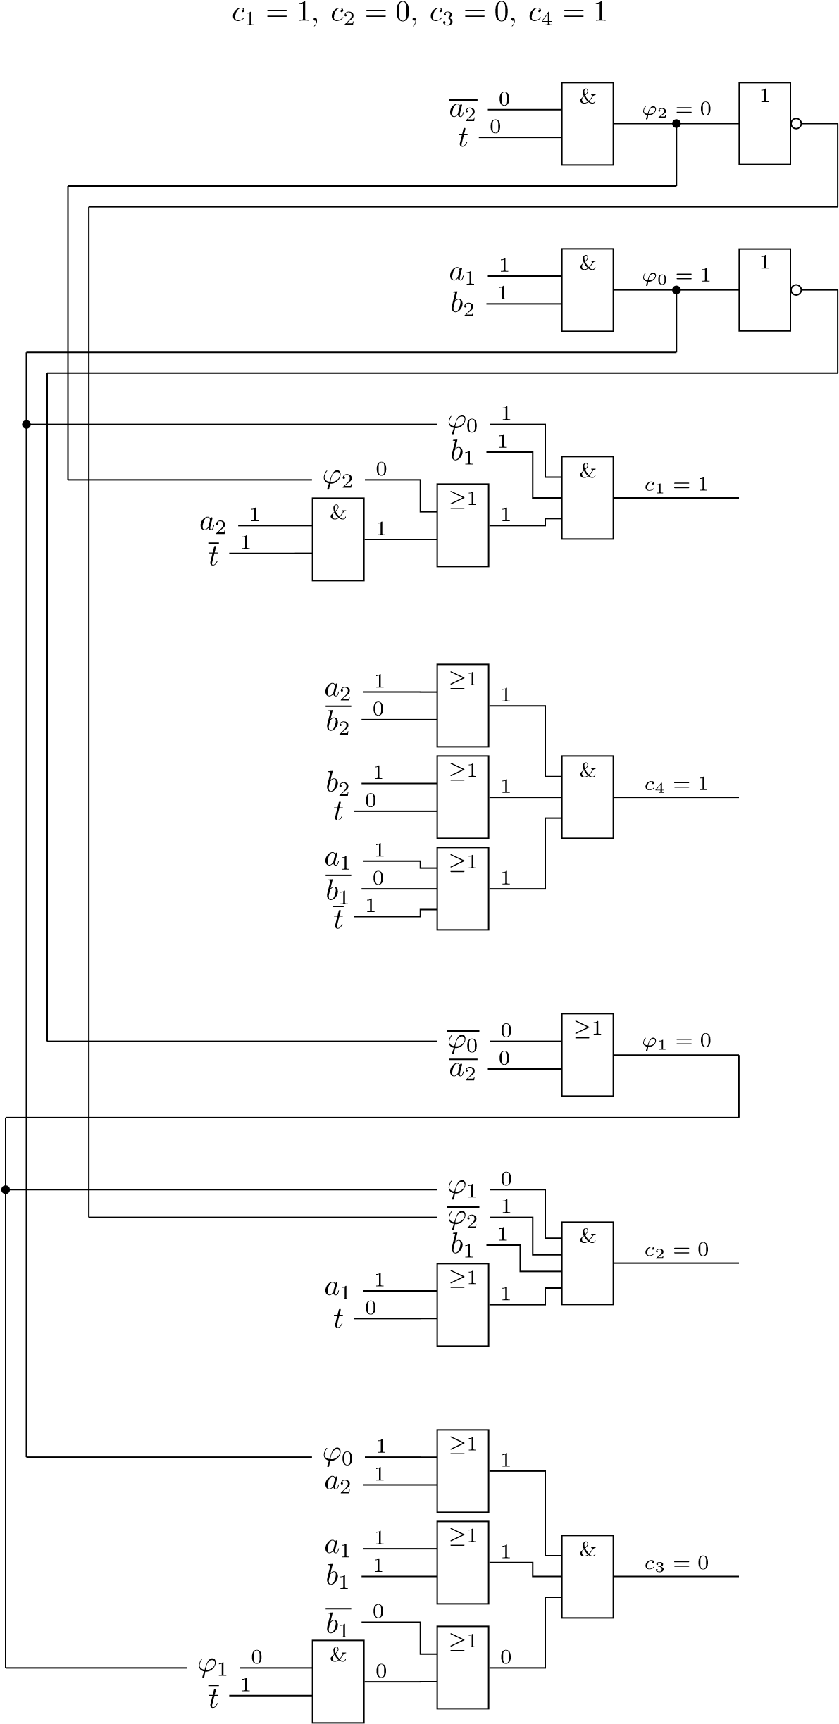

Цена схемы: *SQ* = 42. Задержка схемы: *T* = 6*τ*.